**How to use selenium to do the automatic tests**

--Yike Xue (Eva)

1. Please make sure you have installed Firefox browser and add the Selenium IDE in this browser.

a. install Firefox browser:

http://mozilla-firefox.todownload.com/

b. install Selenium IDE: (Please install Firefox first and use the new browser to download the Selenium IDE—click on the version number 🡪 download 🡪 add to firefox)

<http://seleniumhq.org/download/>

c. install PHP Formatters(use Firefox browser)

<https://addons.mozilla.org/en-US/firefox/addon/selenium-ide-php-formatters/>

d. use the Selenium IDE in Firefox browser

open the firefox browser, press “ALT” to show the tools tab, select “Selenium IDE” and open a new window like the following:

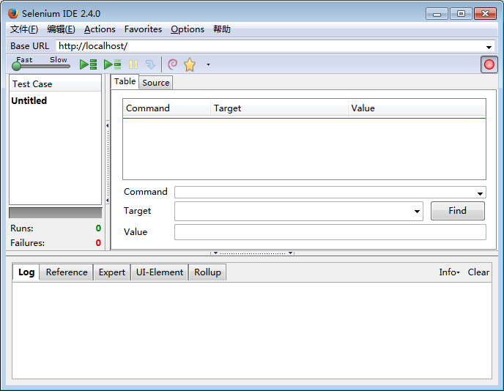

**2.Replay the test**

**1.Open a test case**

**Start/Stop the record**

You can view the test cases stored on your machine or start to record a new test.

If you need to test the same function as a test case with different values of input, you can modify the PatientTest1.php file like the following image:

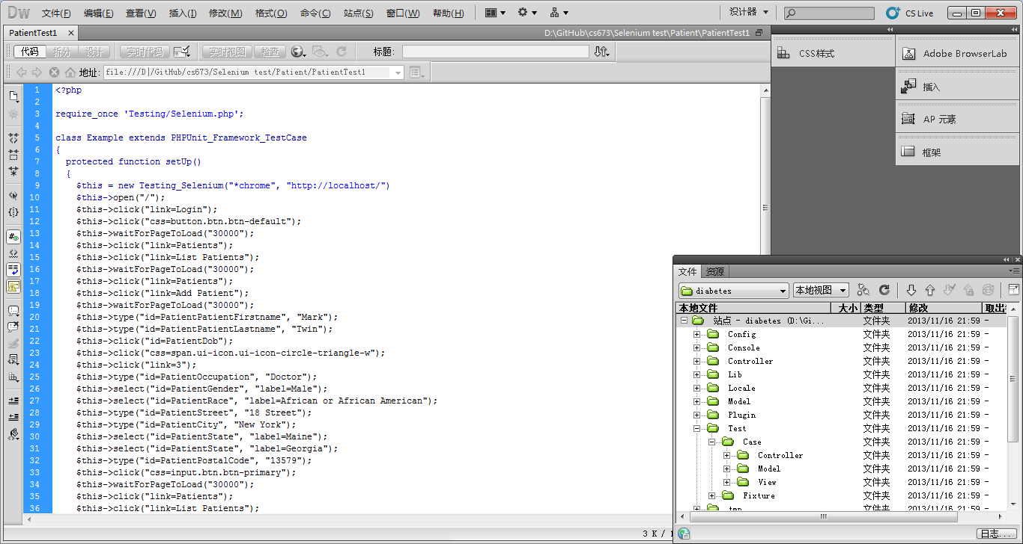

There are more details about Selenium IDE on the website: <http://www.codediesel.com/php/selenium-ide-tutorial-part-2/>

2. Please make sure you have installed PHPUnit on your machine.

3. Please download Selenium RC Server and Selenium Client & WebDriver Language Bindings

http://docs.seleniumhq.org/download/

(For your convenient, some of the tools are included in the "tools" file in GitHub. In case you cannot use the provided version, I suggest you download the appropriate version from the Internet)